The Sagran Archipelago.
“The depths of men’s hearts hide terrors darker than the deepest Abyss.” – The Mauryan.

Overview
Long ago the Hegemony of Agnaroth held complete dominion over the Hundred Isles of the Sagran Sea. The Hegemon, and his seven Viziers, ruled the archipelago from Shikhar Minar, the Tower of Flames, built across the mouth of Agni, the great dormant volcano at the center of Agnaroth.
The Agnarians ruled for centuries, raising great golden towers on their homeland while brining both order and tyranny to the smaller isles around them. Their Hegemony would have survived many, many more centuries if it were not for the Upheaval– a series of unnaturally violent natural disasters that saw the Isle of Agnaroth vanish beneath the waves.
Nearly a millenia later the Isle of Agnaroth has returned; risen from its watery grave like a sea-wraith out for vengeance. And with its resurrection, it has brought the lure of treasure and adventure. Adventurers, pirates, privateers and their ilk have begun to flood the Archieplago in search of Agnaroth’s famous treasures, and it is only a matter of time before their conflicting interests bring war to the Archipelago once again.

History
“Let water, not blood, nourish our lands. Let unity, not sorcery, rule our hearts.” – The Mauryan.

The Hegemony did not long outlive the sudden destruction of its capital. Agnaroth had been more than its biggest city. It had been the political, social and cultural geo-center of the entire archipelago, and its loss created a massive power vacuum, and saw the entire region descend into total anarchy. This period in history, known to scholars as the Matsyanyam, lasted for more than a century.
It wasn’t until the coming of the mysterious figure, known only as the Mauryan, that the fighting started dying down. By then, millions of lives had been lost in the unrest – almost a hundred times more than those lost in the Upheaval. Of the Hundred Isles only twenty four remained inhabited.
The man, who would become the Mauryan, it is said, was once the Sorcerer-chieftain of the Isle of Kandahar – a man who delighted in using witchcraft to best those he considered his “lesser”. But when he saw for the first time the ruin his thirst for power had brought to the tiny fishing village of Marsan, he was horrified. The men had long since been slain in battle, and the women, unwilling to let themselves or their wards become “spoils” of war had decided to join their husbands, brothers and fathers. All along the streets were arranged the corpses of women and children – a macabre “gift” to those who wished to conquer them. Everyone in the village was dead – everyone, that is, except for a single orphan who had no loved ones left to deliver him “mercy.” The boy, having nothing left to lose, rushed straight at the Sorcerer. But instead of an angry, violent outburst the child merely retorted by weeping. He clutched the Sorcerer’s bright crimson robes and cried his eyes out. His tears melted the Sorcerer’s heart like the flames of Agni and the Sorcerer wept with him. It is said that they wept together for days on end and, when the Sorcerer finally regained composure, he was a different man.
Swearing off violence, his name, his title, and his sorcery, the Sorcerer became the Mauryan, the pacifier, and dedicated his entire life to stopping the senseless violence that had enveloped the Archipelago. Every day more and more people joined his cause until, one day, the news of the Mauryan Movement had spread all over the Islands – from easternmost D’ahuk to Pourov on the Westereef and even farther south to the mainland of Janmabhumi across the Sagran Sea. Sadly, the Mauryan did not live to see his dream of pacifism reach its conclusion. The knife of a Kandarian Assassin made sure of that.
Even on his deathbed the Mauryan implored Partho, the orphan from Marsan and his successor, to establish lasting peace between the islands. But, Partho had become disillusioned after losing two father figures in the same conflict. Thinking that it was the diversity between the Islands that was the source of the violence, Partho created the Vanga Edict which forbade travel and communication between the Isles. To enforce the Edict, Partho created the Swanti Bahini, an army fanatically devoted to the Mauryan movement to the point where they would use extreme violence as a means to “maintain the peace.”

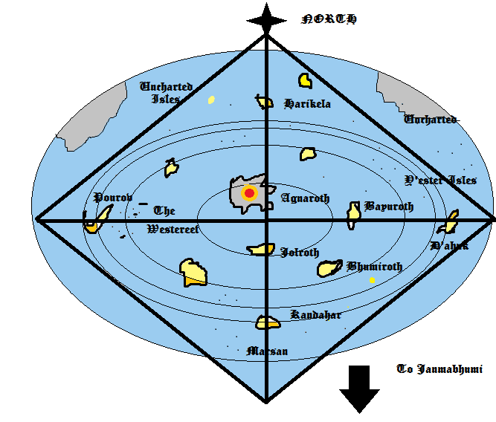
Figure 1 The Sagran Archipelago : Central Isles

Magic
Sorcery has been banned in the archipelagos by the Swanti Bahini but in the Age of the Hegemony, Sagrian sorcerers wielded the power of the waves. Only the Agnorians had knowledge of Pyromancy but the secretive and selective nature of Pyre Mages made sure that Agnorians took their secrets to the grave with them. It is said that the unquiet lost souls of those perished at sea powered the Hydromancer’s craft. While horrifying in itself, this fact also his raises the question of how exactly the Agnorians managed to refine their control of fire.

Flora and Fauna
Though the most common by far, humans aren’t the only sentient beings to call the archipelagos home. The serpentine Naga, the monstrous Ra’kshasa and the enigmatic P’ori all inhabited the islands at some point in time. Most of them were slain by the Hegemony when it first rose to power. But some say they (or maybe their spirits) still haunt the dead islands that line the uncharted waters west of Pourov.

Technology
While once capable of metallurgy, the Isles have regressed technologically overall to the point that wooden stone-tipped spears are the weapon of choice for hunting parties. The scarcity of stone on most of the Isles have left most of their major cities a collection of thatched huts with a few mud houses thrown in between.
The Longlanders, though, are a different matter entirely. To say that they eclipse the islanders technologically is an understatement. Arriving in the archipelago in their iron, steam-powered ships and armed with hand-canons and mechanical, heavy metal plate mail, most islanders, Swanti Bahini notwithstanding, submitted to their whims willingly. For the most part the Longlanders have treated the islanders with respect. The main conflict arises between different Longlander expeditions who are competing with each other to establish dominance in the region for their respective nations.
Drohull, Arkados, Lernasian Empire and the Schinessal Republic are but a few of the sovereignties vying for power. But, to most Islanders, they are little more than names.

Plot Overview
The return of Agnaroth has brought more than treasure hunters to the Archipelago . It has brought winds of change. The great Iron-ships of the mainlanders (or “Longlanders” as they are called by the locals) frequently travel between islands to recruit more crewmen while the Swanti Bahini, being reduced to a mere shadow of its former selves, is now unable to regulate the Vanga Edict effectively.
In short, the conditions are ideal for a young, daring Islander to leave behind his dull life of isolation and embark on a journey of a lifetime across the archipelago. Opportunities abound and whether you adopt the path of an honest merchant, a thieving buccaneer or a daring thrill-seeker is all up to you.
Starting off as an individual raised under the tenants of the Mauryan, the protagonist has no combat skills to speak. But the hero of our story is…resourceful…if nothing else and, after a short incident involving a beached Longlander ship, a brutally drunk captain an inevitable mutiny, he’ll find himself onboard the Aurient as an officer. Fortune smiles on our young hero who soon climbs up the ranks to become captain. But that’s all just the prologue.
Trade, diplomacy and guile are the name of the game as you sail from island to island, utilizing (or abusing) the volatile political situation to make the archipelago (or just yourself) richer overall. Hire mercenaries (and, eventually entire ships) to guard you and your goods. Convince isolated natives to trade you their goods for a fair(or not so fair) profit. Establish settlements in the eighty or so uninhabited (and, in some cases, haunted) islands and leave your legacy carved eternally into the sands.
But that’s not all. A dark shadow looms over the resurrected island of Agnaroth and only the enlightened will be able to piece together history and put the (metaphoric and literal) spirits of the Hegemony to rest once and for all.

